MAMPS
Maternity.Acupuncture.Mentoring.Peer Support
Dedicated to developing and supporting expertise in maternity acupuncture care

Framework for safe acupuncture practice when treating:
Polyhydraminos
This document has been prepared by the MAMPS advisory group. It aims to provide guidance for acupuncturists regarding safe clinical practice and referral considerations as assessment prior to your diagnosis and treatment plan.
Disclaimer: This information should not be relied on as a substitute for medical information.
Professional Safety /Red flags when treating Polyhydraminos
Not all pregnancies with polyhydraminos are suitable for acupuncture treatment. Practitioners need to be aware of risk factors, particularly those due to PROM and cord prolapse. Best practices include the suggested clinical documentation guidelines (shown below), awareness of AFI values and fetal position, primary care/medical monitoring and familiarity with the risks factors and contraindications to acupuncture treatment when polyhydraminos is present, particularly in late pregnancy.

Background: Polyhydramnois is characterized by a high amniotic fluid index (AFI) of at or above 24cm or a vertical pocket of 8cm or more. Although the majority of polyhydraminos cases are idiopathic, conditions such as multiple gestation, gestational diabetes, fetal-maternal hemorrhage, fetal abnormalities, or infection are associated with polyhydraminos. When a patient receives diagnosis of polyhydraminos it can be important to reassure the parents that this finding is often idiopathic in nature.
Difficulty breathing, lower body edema, lower back pain, heartburn and nausea can all become problematic in polyhydraminos due to the increased size of the uterus. While these symptoms can be helped by acupuncture in clinic, it is important to recognize that polyhydraminos carries risk of preterm labor, PROM, cord prolapse, malposition of the baby, placenta abruption and the potential for postpartum hemorrhage. These risks should be taken into consideration when creating a treatment plan, particularly in relation to prebirth and labor facilitation treatments outside of the hospital prior to a medical induction. Precautions should also be taken by acupuncturists providing treatment during labor in an out of hospital setting.
Risk factors that require consideration: Due to high levels of fluid the fetus may have an unstable lie in the uterus and not be well positioned or well engaged. This presents a risk for cord prolapse should membranes rupture.
Application to Clinical Practice
Best practice when treating patients with polyhydraminos includes documenting AFI values and fetal position (if known) and understanding the primary medical management plan for labor and birth. Due to increased risk factors in late pregnancy particular caution should be given with prebirth and labor facilitation acupuncture and continuing communication with the primary caregiver regarding is recommended

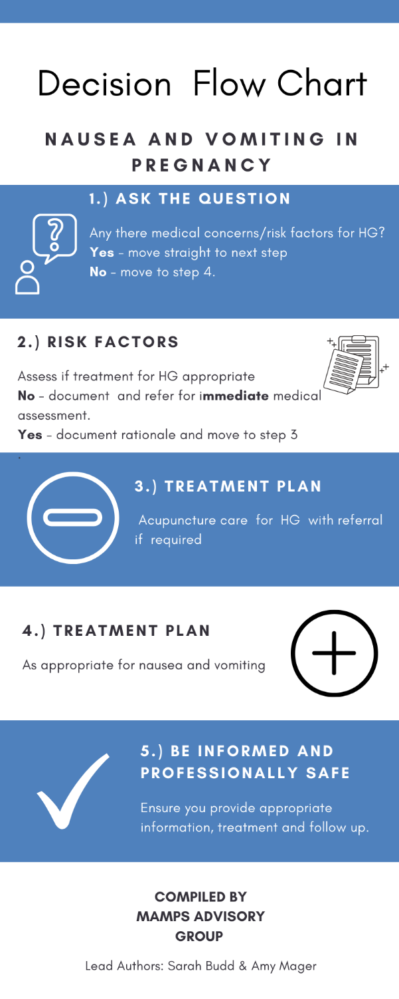
Example: This needs to be done in a separate programme but if you can provide the wording much appreciated !

Recommended reading:
King, T. L. (2013). Varney's midwifery. Fifth edition. Burlington, Massachusetts: Jones & Bartlett Learning.

Guidelines

Websites :
“Polyhydramnios.” (2021) The Fetal Medicine Foundation, fetalmedicine.org/education/fetal-abnormalities/amniotic-fluid/polyhydramnios.

LANGUAGE FOR DECISION FLOW CHART

Decision Flow Chart - Polyhydraminos in late pregnancy
1.COMMUNICATE WITH MEDICAL CARE Do AFI levels and fetal lie present significant concerns in late pregnany.
YES - Move to Step 3
NO - Move to next step

2. DOCUMENT Document your communication with primary medical care. Move to Step 4.

3. AVOID OUT OF HOSPITAL TREATMENT FOR LABOR PREPARATION

4. APPROPRIATE TREATMENT Create a treatment plan that does not increase risk factors.

5. BE INFORMED AND PROFESSIONALLY SAFE Ensure provide appropriate information, treatment and follow up.

Appropriate documentation for professional safety & when presenting as case history
- Gestational age in weeks and pregnancy history -(number of pregnancies and live births)
- Any risk factors of concern/contraindications
- Test restults for AFI and documentation of last known fetal presentation
- Medical monitoring and management plan for late pregnancy, labor and birth
- Your diagnosis and treatment plan
- Continuing communication with primary medical caregiver, as appropriate.

